Class loaders
Introduction

Class loaders are instances of subclasses of the abstract java.lang.ClassLoader class. Their primary purpose is to obtain class definitions (i.e., code) for classes whose names they are passed. This function is performed by each class loader’s loadClass method, which takes as input a class name, and returns a java.lang.Class object representing the loaded class.
Inside the class loader, this translates into several steps: first, the class loader checks if it has previously loaded a class of the given name, and if so, returns that class. If no such class has been loaded yet, then the class loader obtains (through means specific to itself) a definition for the class, formatted as a Java class file. Finally, the class loader reifies the class by defining it—passing its definition to the Java Virtual Machine (JVM), which hands back a representative Class object.

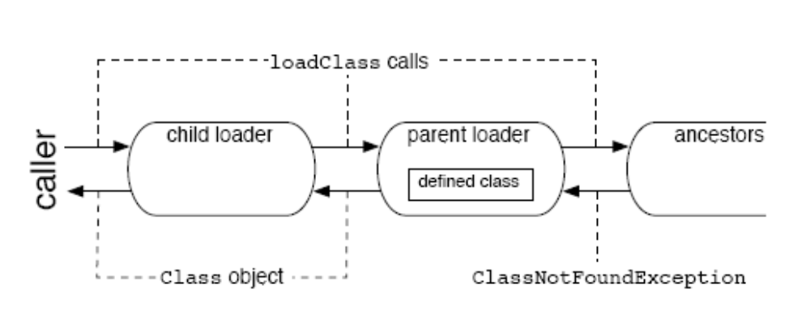
Figure 1: Class loader delegation

Well-known class loaders

The following class loaders are present in each Java process running JDK1.2.
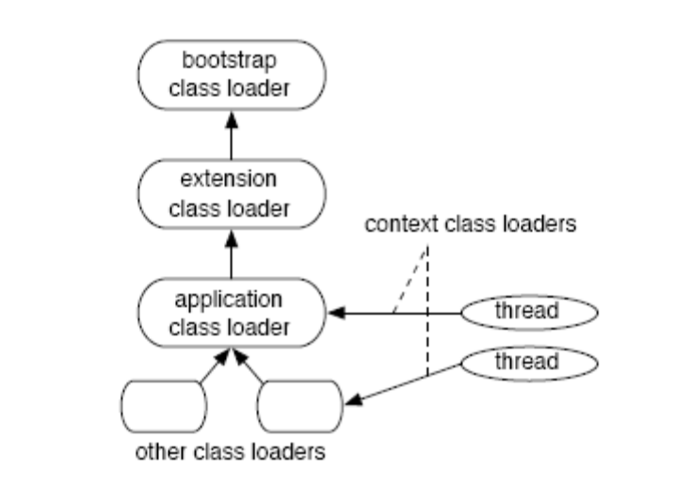
Figure 2: Well-known class loaders

Bootstrap class loader: This class loader loads system classes, such as those belonging to the various java.* packages. Where and how these classes are actually stored may vary between JVM implementations. This class loader is also known as the primordial or null class loader.

Extension class loader: This class loader loads classes from Java Archive (JAR) files present in the standard extensions directory for the Java process.

Application class loader: This class loader loads classes from within directories or JAR files specified by the class path of the Java process. As this is the default class loader returned by the ClassLoader.getSystemClassLoader() method, it is sometimes called the system class loader.

Context class loader: A context class loader is associated with a Thread. This class loader is provided by the thread creator to code running in the thread for the purpose loading classes and resources. This class loader is useful for loading classes and resources that are not always available to the class loader which loaded the code running in the thread.

java.lang.ClassLoader
A class loader is an object that is responsible for loading classes. The class ClassLoader is an abstract class. Given the binary name of a class, a class loader should attempt to locate or generate data that constitutes a definition for the class. A typical strategy is to transform the name into a file name and then read a "class file" of that name from a file system.
Every Class object contains a Class.getClassLoader() reference to the ClassLoader that defined it.
Class objects for array classes are not created by class loaders, but are created automatically as required by the Java runtime. The class loader for an array class, as returned by Class.getClassLoader() is the same as the class loader for its element type; if the element type is a primitive type, then the array class has no class loader.
Applications implement subclasses of ClassLoader in order to extend the manner in which the Java virtual machine dynamically loads classes.
Class loaders may typically be used by security managers to indicate security domains.
The ClassLoader class uses a delegation model to search for classes and resources. Each instance of ClassLoader has an associated parent class loader. When requested to find a class or resource, a ClassLoader instance will delegate the search for the class or resource to its parent class loader before attempting to find the class or resource itself. The virtual machine's built-in class loader, called the "bootstrap class loader", does not itself have a parent but may serve as the parent of a ClassLoader instance.
Normally, the Java virtual machine loads classes from the local file system in a platform-dependent manner. For example, on UNIX systems, the virtual machine loads classes from the directory defined by the CLASSPATH environment variable.
However, some classes may not originate from a file; they may originate from other sources, such as the network, or they could be constructed by an application. The method defineClass converts an array of bytes into an instance of class Class. Instances of this newly defined class can be created using Class.newInstance.
The methods and constructors of objects created by a class loader may reference other classes. To determine the class(es) referred to, the Java virtual machine invokes the loadClass method of the class loader that originally created the class.
For example, an application could create a network class loader to download class files from a server. Sample code might look like:
ClassLoader loader = new NetworkClassLoader(host, port);
Object main = loader.loadClass("Main", true).newInstance();
. . .

The network class loader subclass must define the methods findClass findClass and loadClassData to load a class from the network. Once it has downloaded the bytes that make up the class, it should use the method defineClass to create a class instance. A sample implementation is:
class NetworkClassLoader extends ClassLoader {
String host;
int port;

public Class findClass(String name) {
byte[] b = loadClassData(name);
return defineClass(name, b, 0, b.length);
}

private byte[] loadClassData(String name) {
// load the class data from the connection
. . .
}
}

Binary names
Any class name provided as a String parameter to methods in ClassLoader must be a binary name as defined by the Java Language Specification.
Examples of valid class names include:
"java.lang.String"
"javax.swing.JSpinner$DefaultEditor"
"java.security.KeyStore$Builder$FileBuilder$1"
"java.net.URLClassLoader$3$1"

- The Void (java.lang.Void) class is an uninstantiable placeholder class to hold a reference to the Class object representing the Java keyword void.
- Instances of the class Class represent classes and interfaces in a running Java application. Every array also belongs to a class that is reflected as a Class object that is shared by all arrays with the same element type and number of dimensions. The primitive Java types (boolean, byte, char, short, int, long, float, and double), and the keyword void are also represented as Class objects.

